Bahria University

Karachi Campus



LAB EXPERIMENT NO.

5

LIST OF TASKS

|  |  |
| --- | --- |
| TASK NO | OBJECTIVE |
| 1 | Connect 4 switches A, B, C and D, all switches must be password protected (encrypted password) and apply the following configuration, show network topology and configuration in your lab task. |
|  | Switch B, C, D must be connected to switch A |
|  | Switch B with VLAN name Faculty & Students having 5 logical ports each |
|  | Switch C with VLAN name Management having 3 logical ports |
|  | Switch D with VLAN name SRC & NCMPR having 3 logical ports each |

Submitted On:

2-Nov-2023

(Date: DD/MM/YYYY)

**LAB 05 Virtual Private Network(VPN)**

**SOLUTION**

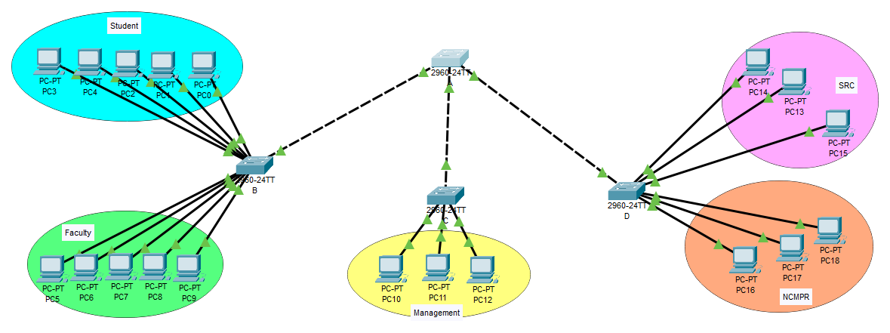

**SWITCH A ENCRYPTED PASSWORD**

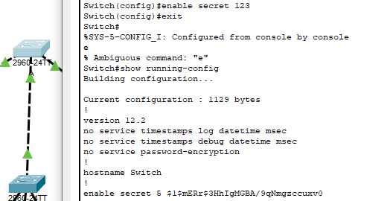

**SWITCH B ENCRYPTED PASSWORD**

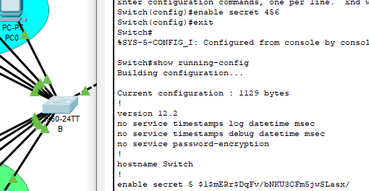

**SWITCH C ENCRYPTED PASSWORD**

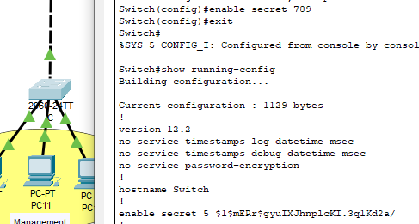

**SWITCH D ENCRYPTED PASSWORD**

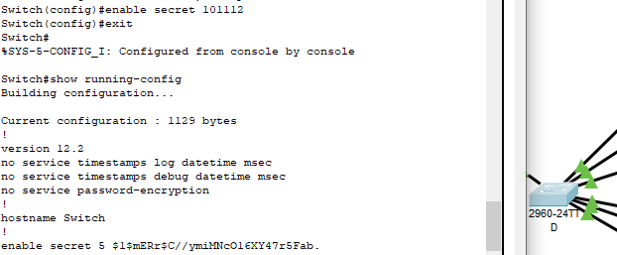

**SWITCH B VLAN CONFIGURATION**

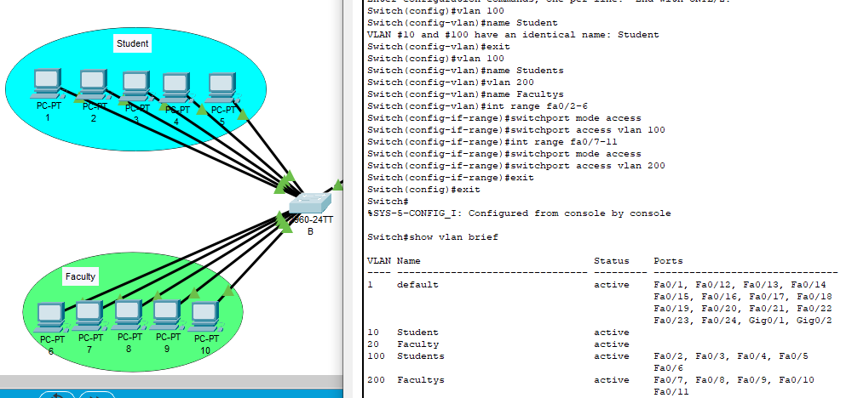

**SWITCH C VLAN CONFIGURATION**

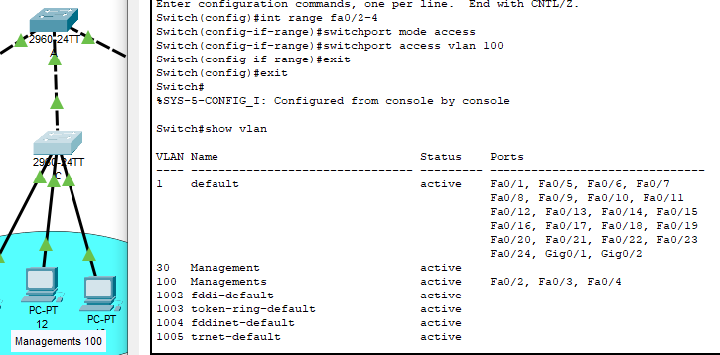

**SWITCH D VLAN CONFIGURATION**

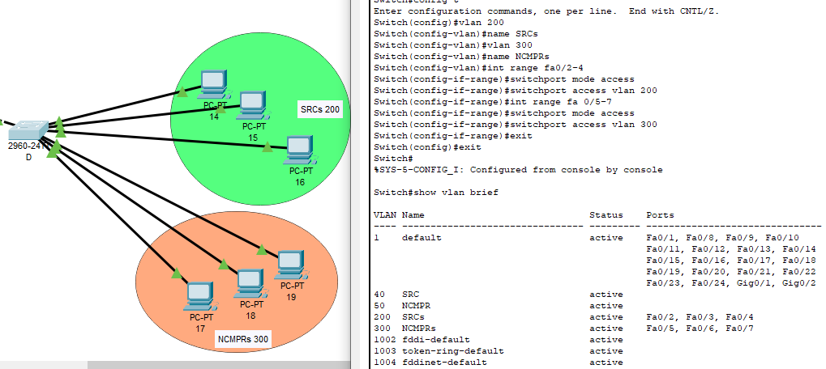

**TRUNK SWITCH A**

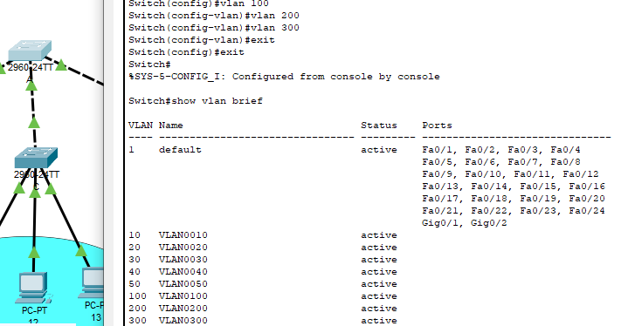

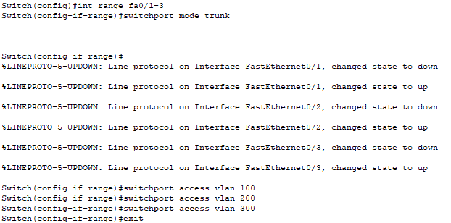

**Faculty to SRC**

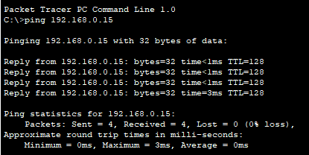

**Student to SRC (Failed)**

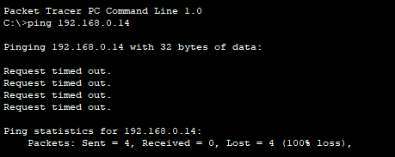

**Student to Management**

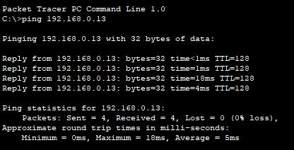

**Management to Management**

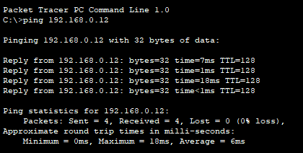

**Student to NCMPR**

